VIVA Course Materials Survey - Default Report
Virginia Course Materials Survey - Revised
January 26th 2022, 4:25 pm EST

Degree - What degree or award are you currently pursuing:
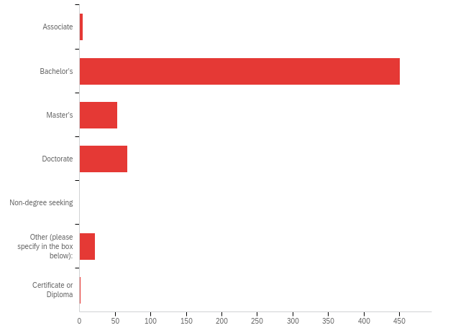

# | Field | Minimum | Maximum | Mean | Std Deviation | Variance | Count
1 | What degree or award are you currently pursuing: - Selected Choice | 14.00 | 20.00 | 15.47 | 1.00 | 1.00 | 600

# | Answer | % | Count
14 | Associate | 0.83% | 5
15 | Bachelor’s | 75.17% | 451
16 | Master’s | 8.83% | 53
17 | Doctorate | 11.17% | 67
18 | Non-degree seeking | 0.00% | 0
19 | Other (please specify in the box below): | 3.67% | 22
20 | Certificate or Diploma | 0.33% | 2
 | Total | 100% | 600

Q2_19_TEXT - Other (please specify in the box below):
Other (please specify in the box below): - Text
J.D.
JD
Undergraduate
JD
JD
JD
JD
JD
JD
JD
JD
MD
J.D.
JD
law
J.D.
Master's and Doctorate
Medical
M.D.
MD
JD
J.D.

Credit Hours - Approximately how many credit hours have you completed?
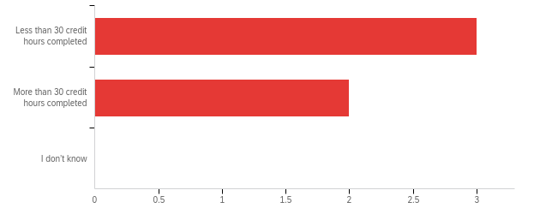

# | Field | Minimum | Maximum | Mean | Std Deviation | Variance | Count
1 | Approximately how many credit hours have you completed? | 1.00 | 2.00 | 1.40 | 0.49 | 0.24 | 5

# | Answer | % | Count
1 | Less than 30 credit hours completed | 60.00% | 3
2 | More than 30 credit hours completed | 40.00% | 2
3 | I don’t know | 0.00% | 0
 | Total | 100% | 5

Academic Level - What is your current academic level?
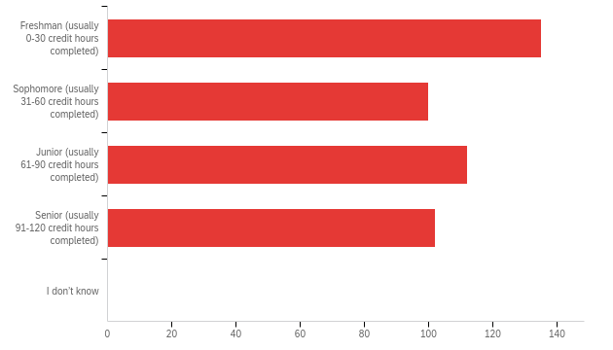

# | Field | Minimum | Maximum | Mean | Std Deviation | Variance | Count
1 | What is your current academic level? | 1.00 | 4.00 | 2.40 | 1.14 | 1.30 | 449

# | Answer | % | Count
1 | Freshman (usually 0-30 credit hours completed) | 30.07% | 135
2 | Sophomore (usually 31-60 credit hours completed) | 22.27% | 100
3 | Junior (usually 61-90 credit hours completed) | 24.94% | 112
4 | Senior (usually 91-120 credit hours completed) | 22.72% | 102
5 | I don’t know | 0.00% | 0
 | Total | 100% | 449

Number of Courses - During the current semester or quarter, how many courses are you taking?
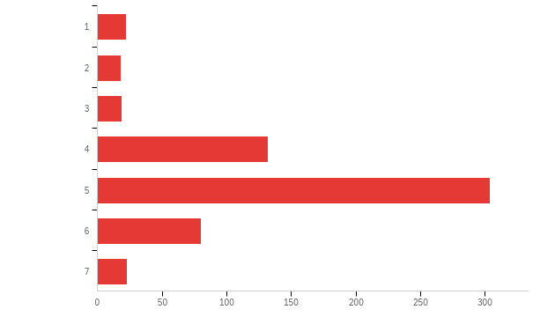

# | Field | Minimum | Maximum | Mean | Std Deviation | Variance | Count
1 | During the current semester or quarter, how many courses are you taking? | 1.00 | 7.00 | 4.69 | 1.18 | 1.40 | 598

# | Answer | % | Count
1 | 1 | 3.68% | 22
2 | 2 | 3.01% | 18
3 | 3 | 3.18% | 19
4 | 4 | 22.07% | 132
5 | 5 | 50.84% | 304
6 | 6 | 13.38% | 80
7 | 7 | 3.85% | 23
 | Total | 100% | 598

Required Materials - During the current semester or quarter, how many courses required you to buy course materials (e.g. textbooks, access codes, courseware, online subscriptions)?
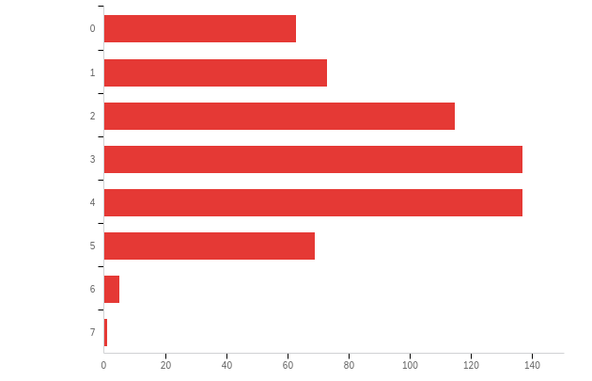

# | Field | Minimum | Maximum | Mean | Std Deviation | Variance | Count
1 | During the current semester or quarter, how many courses required you to buy course materials (e.g. textbooks, access codes, courseware, online subscriptions)? | 1.00 | 8.00 | 3.74 | 1.53 | 2.35 | 600

# | Answer | % | Count
1 | 0 | 10.50% | 63
2 | 1 | 12.17% | 73
3 | 2 | 19.17% | 115
4 | 3 | 22.83% | 137
5 | 4 | 22.83% | 137
6 | 5 | 11.50% | 69
7 | 6 | 0.83% | 5
8 | 7 | 0.17% | 1
 | Total | 100% | 600

Number of Purchases - For how many of these courses did you actually buy (as opposed to rent) all of the required course materials?
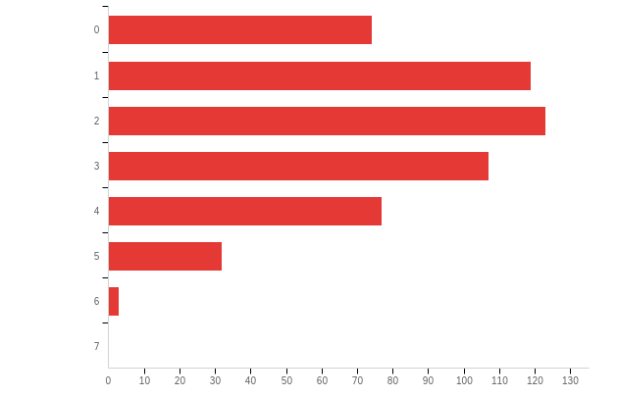

# | Field | Minimum | Maximum | Mean | Std Deviation | Variance | Count
1 | For how many of these courses did you actually buy (as opposed to rent) all of the required course materials? | 1.00 | 7.00 | 3.19 | 1.46 | 2.14 | 535

# | Answer | % | Count
1 | 0 | 13.83% | 74
2 | 1 | 22.24% | 119
3 | 2 | 22.99% | 123
4 | 3 | 20.00% | 107
5 | 4 | 14.39% | 77
6 | 5 | 5.98% | 32
7 | 6 | 0.56% | 3
8 | 7 | 0.00% | 0
 | Total | 100% | 535

Spend - About how much did you spend on course materials, whether purchased, leased, or rented, during this semester? A guess is OK.
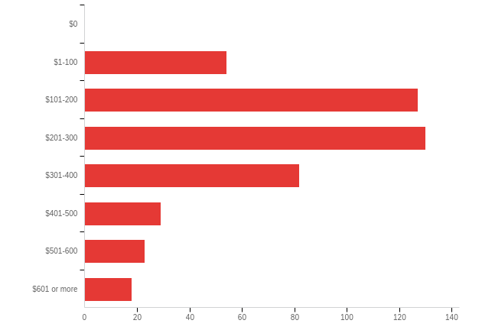

# | Field | Minimum | Maximum | Mean | Std Deviation | Variance | Count
1 | About how much did you spend on course materials, whether purchased, leased, or rented, during this semester? A guess is OK. | 2.00 | 8.00 | 4.10 | 1.49 | 2.23 | 463

# | Answer | % | Count
1 | $0 | 0.00% | 0
2 | $1-100 | 11.66% | 54
3 | $101-200 | 27.43% | 127
4 | $201-300 | 28.08% | 130
5 | $301-400 | 17.71% | 82
6 | $401-500 | 6.26% | 29
7 | $501-600 | 4.97% | 23
8 | $601 or more | 3.89% | 18
 | Total | 100% | 463

Level of worry - How worried were you about meeting your course material costs this semester?
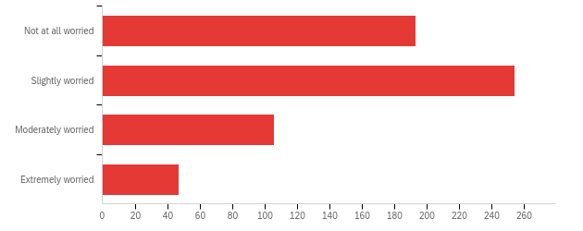

# | Field | Minimum | Maximum | Mean | Std Deviation | Variance | Count
1 | How worried were you about meeting your course material costs this semester? | 1.00 | 4.00 | 2.01 | 0.90 | 0.81 | 600

# | Answer | % | Count
1 | Not at all worried | 32.17% | 193
2 | Slightly worried | 42.33% | 254
3 | Moderately worried | 17.67% | 106
4 | Extremely worried | 7.83% | 47
 | Total | 100% | 600

Impact of Costs - In your academic career, has the cost of required course materials caused you to:
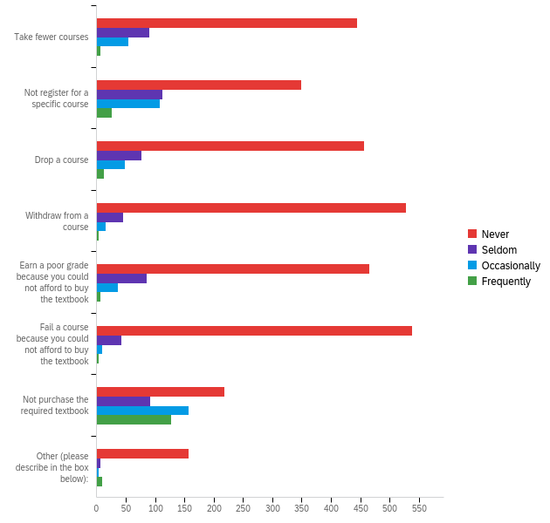

# | Field | Minimum | Maximum | Mean | Std Deviation | Variance | Count
1 | Take fewer courses | 1.00 | 4.00 | 1.37 | 0.70 | 0.49 | 597
2 | Not register for a specific course | 1.00 | 4.00 | 1.68 | 0.92 | 0.84 | 596
3 | Drop a course | 1.00 | 4.00 | 1.35 | 0.71 | 0.51 | 593
4 | Withdraw from a course | 1.00 | 4.00 | 1.15 | 0.47 | 0.22 | 593
5 | Earn a poor grade because you could not afford to buy the textbook | 1.00 | 4.00 | 1.30 | 0.63 | 0.39 | 593
6 | Fail a course because you could not afford to buy the textbook | 1.00 | 4.00 | 1.12 | 0.43 | 0.18 | 595
7 | Not purchase the required textbook | 1.00 | 4.00 | 2.32 | 1.18 | 1.38 | 594
8 | Other (please describe in the box below): | 1.00 | 4.00 | 1.23 | 0.72 | 0.52 | 176

# | Question | Never |  | Seldom |  | Occasionally |  | Frequently |  | Total
1 | Take fewer courses | 74.54% | 445 | 15.08% | 90 | 9.21% | 55 | 1.17% | 7 | 597
2 | Not register for a specific course | 58.56% | 349 | 18.96% | 113 | 18.12% | 108 | 4.36% | 26 | 596
3 | Drop a course | 77.07% | 457 | 12.82% | 76 | 8.09% | 48 | 2.02% | 12 | 593
4 | Withdraw from a course | 89.04% | 528 | 7.59% | 45 | 2.70% | 16 | 0.67% | 4 | 593
5 | Earn a poor grade because you could not afford to buy the textbook | 78.41% | 465 | 14.33% | 85 | 6.24% | 37 | 1.01% | 6 | 593
6 | Fail a course because you could not afford to buy the textbook | 90.59% | 539 | 7.06% | 42 | 1.68% | 10 | 0.67% | 4 | 595
7 | Not purchase the required textbook | 36.70% | 218 | 15.49% | 92 | 26.43% | 157 | 21.38% | 127 | 594
8 | Other (please describe in the box below): | 89.20% | 157 | 3.98% | 7 | 1.70% | 3 | 5.11% | 9 | 176

Educational Progress - Can you please tell us more about how the cost of course materials has influenced your educational progress?

Can you please tell us more about how the cost of course materials has influenced your educational progress?
If there are courses where I know the professor will require us to purchase a lot of books, I will avoid taking those courses.
The more expensive the course materials, the less likely I am to buy it.
It has hinder the type of courses I signed up for.
I have often had to purchase a book to share with other students in my class, which was inconvenient at times and required extra planning, but was the only financially viable option.
If two courses seem about equivalent in interesting and requirements, then if one has books for $50 and the others are free, I would pick the free one very often.
If there are high cost course materials, I'll either look for cheaper options or just not purchase the materials at all
Each of my classes require at least five books/textbooks to be purchased. I absolutely hate purchasing a book I will only use for maybe three months and never use again. It is a waste of my resources and money. Additionally, if the book is so expensive that I choose not to purchase it, I miss vital concepts and important information necessary for doing well in the class.
I often have to research or do extensive work to find cheap or rentable versions of textbooks, often settling for Kindle versions (against a professor's wishes) or a free pdf version online. As an English major this means I'm often lost or cannot follow instruction in class as my books are almost always different versions--and oftentimes I cannot write notes or highlight as my professor wishes.
On top of the extremely high cost of tuition and other semester fees, paying for course materials is very stressful. My experience as a UVA student would have been considerably better if course materials were cheaper.
Mostly I have chosen not to purchase textbooks due to their high cost and short usage period unless I know in advance that assessments are based primarily or exclusively on the textbook(s)
I had a professor who made me buy print copies after i bought ebooks which was a waste of fucking money :)))
I have used a textbook from a classmate because I couldn't afford to buy the book
I've been fortunate enough to be able to afford most of my textbooks or at least find cheap/free versions of them online -- problems generally emerge when I have to buy special software/online textbooks to complete a course because I work better with physical textbooks and I have had to drop course where I'm forced to buy a nonrefundable/expensive online textbook/program to complete the course because it's very expensive and I didn't want to commit to the course in that way.
Not a lot, but being able to have more material means more practice questions an tests which can help to do better.
decision to buy one book rather than another. maybe purchase the book later, if used in the course
The more I spend on textbook the less money I have to eat.
This is my first semester I am doing a big, full time load of classes. In the past, part of my reason for doing part time was the cost of the class itself and the textbooks. It can get so expensive and you are required to have these materials or you won't pass.
I try to find a free PDF online which may be outdated
Most of the time I try to find materials required for the class through websites with free pdf's unless I need to buy a software or subscription where homework and class participation is required.
It has stressed me out to the point where I have to choose between groceries and buying the book that month. The stress also is distracting cause I sit in class and the thought of the books I have to buy comes up
Because they’re so expensive I end up not buying them and just settle with getting a free version or just hoping for a summarization in class.
Makes me upset with the University and the professor, especially in circumstances when the prices seem artificially high, the school/professor waits to disclose the textbook requirements in order to force people to buy it from the bookstore, or books are assigned that clearly aren't needed/can be accessed for free.
Because I am entirely responsible for my school costs, it has certainly been difficult, but I have managed as of yet.
I typically spend a lot of time searching for free versions or other resources when I do not buy the textbook
It’s frustrating because as a STEM major, most textbooks are paired with “platforms” where I complete all of my work, making it cost even more. It’s inefficient to make students do work on an excess of platforms and buy so many “subscriptions”. Additionally, most of my classes have online textbooks that require you pay even more to purely rent the hard copy for the year which is frustrating because all we do everyday is look at a screen.
Not sure about my educational progress but definitely stressed in terms of financing my education.
I check out books from the library more often so I don't have to purchase the book.
In general I haven’t skipped courses because of material courses but I lost some specific content that was contained in the courses.
I am less inclined to purchase a book for a course and try to get by without it, versus buying it and not really needing to read it, if that makes sense.
While I don't think the cost of course materials has really influenced my educational progress, it definitely adds a level of stress to the beginning of every semester. I feel like I have to decide right at the beginning of the semester if I'm going to like a class or not in order to warrant buying the materials.
The cost makes it more difficult because I begin to rely on classmates to tell me about the chapter because it is expensive
Usually I will wait until I absolutely need it to try not to waste money which sometimes puts me a bit behind
A lot of classes that have required reading, I will not get the textbook and just base my knowledge off lectures
I frequently do not buy required textbooks, because they are so expensive. I would definitely benefit from having a copy of all my required readings, I'm sure my grades would improve, but it's not worth it comparatively with the high cost and infrequency of use. Some classes use their required texts every class, but others require textbooks and only use them a handful of times. Sometimes I run into scenarios where a specific assignment from class requires reading from the textbook, but I neglected to get it because it was too expensive or wasn't used enough.
I often do not purchase textbooks because of their high cost. Sometimes I can find a previous edition online and use that resources instead. If I cannot find anything online and the course material relies heavily on the book, I may purchase it. I often find that not having the textbook does not usually affect my understanding of material or ability to be successful in the class
I study architecture, so the my courses don't really require me to buy textbooks but mostly stationary and model making materials. I usually try to get the cheapest material, but if it is for the final model I would have to purchase a better material in order for it to be a good model.
It's always something I have to worry about or stress over. I know many friends who experience the same stress; it should not cost this much for us to learn. School already costs enough.
It's another limiting factor for those from disadvantaged backgrounds. Education costs associated with a class should be included in tuition.
My main pet peeve is when a course requires a $300 textbook that was written by the professor. I paid to take this course, don't pick my pocket by making me purchase your book.
I usually try to obtain course materials for free (online, borrowed, etc.) or go without them if they are too expensive.
I am already receiving a high amount of demonstrated financial need, so the cost of course materials throughout my college career is an extra expense about which I worry.
stress inducing
If a textbook is over $100, I would typically wait to see if it was important that I have the book depending on how the class professed.
Cost of course material pushed me to figure out a way to earn a cheaper copy of the material, disregarding legality. That would mean less printed version of the etext which is a shame.
The cost of certain course materials are unnecessary and I try to exhaust all other forms of acquiring the necessary materials before buying the textbook.
The high cost of textbooks and the sheer amount required for courses make it difficult for low-income students to access the materials they need. personally, this has led me to look for other options regarding required texts.
It is obviously much more difficult to learn the coursework when you cannot afford the textbook/additional materials of a course. I have been able to find enough reasons before to still pass classes with decent grades but it certainly was more difficult. Unfortunately, after spedning thousands a semester just to attend a university + park at said university, some materials have to go unpurchased for me.
It is very stressful to try to figure out which books are available at the library, and then compete with dozens of students for 1-2 copies.
The cost of course materials on top of tuition and fees adds additional financial stress to education.
It is an added stress to an already stressful time. It is especially frustrating when professors do not even use the book that I paid $200+ to get for the class.
SOmetimes the course materials have been reccomended, but were essentially critical to attaining a non-failing grade in the class.
In some classes because I know that the books are too expensive, I have decided to share with another classmate or order a one that is either an older addition or less costly. In many cases, I have also had to wait a few weeks in the semester to buy the book causing me to start off behind on readings and homework.
I usually do not buy the textbooks because they are too expensive.
It's annoying that there are required and then not used. You can still learn by knowing just the PowerPoints.
Limits how much I can get out of a course. Frustrating when receiving poor grade due to lack of book.
Often times, I will use an older edition of a textbook or simply do my best in a course without the textbook due to expensive prices.
If course materials are too expensive then usually I will choose to forgo the materials and attempt to find online versions. I may not take the class if the amount goes beyond my ideal price range.
I often don't buy the textbook or get an older outdated version
too poor to afford them
purchasing expensive materials on top of paying for tuition causes increased financial burden and puts my academic success in jeopardy
I cannot afford the materials that my classmates can. For example, though we all must buy the same textbook, helpful additional resources that professor's recommend (modeling kits, clicker remotes, etc.) are out of my budget. While my peers gain a better understanding due to their financial advantage and thus earn better grades, I am left without these resources. Though labeled as "optional", these materials are allowed during exam periods because they truly help students. I am without this help and hence my educational progress is stunted.
I depend on lectures to learn instead of textbooks sometimes
It has made me do worse in classes since I’m not reading
It is very stressful to buy all the required books at the beginning year. I personally don't like the process and it is very unnecessarily stressful.
It is much more than expected for one semester's worth of books.
It has influenced me by causing financial stress and also making me not want to purchase materials I need.
It depends on if the course material is used throughout the semester or only one-time use
Expensive textbooks seem to deter me from signing up for a specific course.
In the past, there have been some resources that I have forgone purchasing in order to save money, and as a result, I have felt that I missed out on getting the full value of my course.
It adds to my debt and has caused anxiety.
I usually just try to find free or much cheaper versions of course materials online because I can't afford the hundreds of dollars they all add up to at the bookstore.
sometimes the more expensive textbooks aren't even used so I feel like it is a waste of money
There were some classes that required homework programs that I had to pay for and it caused me to drop the class even though I really wanted to take it because I couldn't afford the program. Other classes required multiple books or programs to be purchased which added up a lot but since I needed it for my major I couldn't drop the class and it hurt my bank account a lot. I've since resorted to getting textbook pdfs online but pdfs are really hard to read so I haven't used textbooks very much which may have affected my performance in some classes
Aside from my first semester in law school where all of our courses were chosen for us (and we were highly encouraged to purchase from the law school bookstore) - I've shopped around early but rented books from the law school that I knew I'd need to mark up more (more lenient return policy re markings).
You're REALLY focused on the academic aspect of all of this. Do you realize that most students will skip meals, forego transportation, work multiple jobs, in order to pay for their books before they do things like drop a required course or, worse, get a bad grade in a course from their program? Like, Frodo never failed to destroy the One Ring but damn, that doesn't mean it didn't take a toll on him. Just because students aren't taking Ls in class doesn't mean that the exorbitant cost of textbooks (especially for required, core classes) is not causing them to take Ls in life.
It has caused me to choose courses based on their cost.
I refrain from taking classes with expensive textbooks or have had to use less money for food for textbooks.
It most recently has made me request higher loan amounts to help offset tuition costs to be able to buy books out of pocket. My courses are now required so I have to buy the books as compared to undergrad
In a few cases it decreased my ability to learn since I didn’t have the textbook.
It has not affected my grades in courses
I think that because many classes in college require students to buy course materials, I have less willingness to push myself and take more classes and thus learn less.
Being a pre-health student, books are extremely expensive. So much so that I had to take out additional loans to cover them. My first two years I had books that cost 300+ dollars that were required.
As an engineering major, math and science books are usually about $150-200. So I usually will not get them unless the homework must be purchased with it (requiring students to purchase access to homework on its own should be illegal). Thus it often becomes awkward when the professor asks us to reference something in the book, as I usually pull up a free online version. I am by no means a low-income student, but that doesn't mean I have $500 to spend per semester.
The costs of textbooks for university has not hindered my education, but it has weighed into my decisions to drop certain classes that I was on the fence about.
It becomes a big stress at the beginning of classes
It is stressful to spend so much money on books and online memberships that classes require, and I cannot always easily afford these costs.
I have frequently tried to work around using the required textbook. It has worked on occasion when a professor seemingly unnecessarily expected students to purchase it, while in other circumstances I had to make up for the missing material.
Dropped a class because I had to spend 100 dollars just to do the homework on an online textbook/software that I didn’t like
I've been fortunate enough to get by, but I have often foregone purchasing "required" materials especially since a class I took in undergrad REQUIRED $800 of books + a $100 online course access. Again this was for just one class out of 18 credits I was taking. What really got me is we used the online access code one time, and one of the most expensive books we read only one 3 page article out of. Ever since, I refuse to buy books that aren't truly required, even though sometimes I think I've done worse in classes because of it.
I manage to get the items through means of buying used materials or asking around to see if someone has the book or is selling at a lower price.
Just made it difficult to complete certain class readings due to some materials being prohibitively expensive.
It occasionally limits what I can learn because the cost add up and I have to choose which courses I'm going to buy the materials for. This causes extra stress in the courses I chose not to buy and makes the semester difficult.
Stifled the options I have per semester
Buying books is a real strain since it is all front loaded at the beginning of semester. I often struggle to budget the first month of school because the textbooks have eaten my entire living budget.
N/a
It has made it more stressful, it has also made me make extra efforts to try and save money each semester which also caused more stress.
Since I have sometimes decided not to buy course materials to the price, it has affected my educational progress as there are times in which I do not know specific concepts that the class draws on.
I try to buy the fewest materials necessary each semester
As a student on full financial aid, being pressured to buy expensive course materials to complete major requirements had given me lots of unnecessary stress.
I frequently rely on borrowing textbooks within my group or from other members of my cohort in order to study for classes or exams. My classes often require more than a single text for the entire course, and the cost of purchasing all of them would be impossible on my stipend so I usually use the cheapest method to get the most frequently used text.
It separates the students who are financially disadvantaged, from excelling in a course. I have had friends with one literal credit left in their Bachelors degree, drop a required course due to the textbook and online access code requirements. Making someone pay 100$+ just to access homework???!!! It's is highway robbery, and faculty members that practice this should not be allowed to teach students. This practice is classist, ableist, and relies on the assumption that your students have access to wifi, disposable income to purchase these books and codes, and no other choice but to do so.
If a class has expensive textbooks, I may shy away from taking the class.
Course material cost has resulted in me not purchasing some of the necessary course materials to do my best. Additionally, I was discouraged from taking certain classes due to the required material cost.
I have used rented or digital books often which makes it harder for me to learn.
It makes it hard to cover my other basic needs. Sometimes I don't get the books and I'm at a disadvantage to the students who can afford the books.
If some textbooks were more cheaper or not found through infrequently used third-party sites (not the fault of bookstore, but more of instructor) then I would have utilized them more frequently. I liked when everything is streamlined and accessible.
Many courses require course materials that cost over $100 because they figure that is a reasonable cost for a semester, but they forget that EACH class requires this, and it really adds up. Additionally, many classes require multiple course materials to be paid for, requiring lots of money to be spent on one class.
Due to the obscene price of textbooks it puts far further economic strain on myself
It forced me to make a tradeoff between my daily lifestyle and investing in the course materials
I will only buy a textbook if someone I knew took the class and purchased it
If there is a class with multiple required textbooks and a class with none, I always take the cheaper course regardless of match with the professor or potential learning outcomes.
While I am usually able to afford the necessary materials for my courses, it always plays a role in decisions and sacrificing other important things I could spend that money on, such as clothing, entertainment, and other things. I prioritize my education over most things so it has never been a significant issue, but influences other aspects of my life.
Being unable/unwilling to spend hundreds of dollars on textbooks absolutely restricts the information you have access to and makes it considerably more difficult or even impossible to complete work or perform as well on exams
Some of my class materials were quite expensive and it required me to put in more hours for my work just to pay off the textbooks.
Sometimes there are required books for classes but only parts of those books are assigned for reading. In these cases, I don’t buy those books. Luckily for me, I don’t experience this problem as much as other students since I am majoring in design. This semester, all of my classes are design classes, so I use the library to source my own reading picks. I have found that this encourages me to read more, since it is my own desire to learn that fuels this reading, rather than an assignment. I understand that this is a unique case. In the case of buying online materials rather than textbooks in print, I have found that I do not learn very well. The computer screen is straining to the eye, and I prefer to physically annotate and use bookmarks. All of that is harder online.
I feel pressured to buy textbooks that I have seen little actual use of for classes. Feels like an extreme waste of money for no justified reason.
The textbooks end up costing an enormous amount of money and are almost never relied upon by professors. At some point I just decided to not buy any textbooks unless they were very relevant to my future progress (i.e. were in my specialty). They're expensive, hard to move, and hard to sell for a price that isn't a total rip off.
Workarounds have been made to avoid classes where required textbooks incur large costs, i.e. dropping electives, trying to purchase old books from upperclassmen, not purchasing recommended textbooks and trying to find online resources to supplement
While it is easier to learn when you can read the book and write in the physical copy, readings have become much more difficult in every single one of my classes because I am have been forced to find the online version of some of the more expensive and difficult textbooks. It has made it much more difficult to remain on track with my classes.
When I see a course that I want to take has expensive course materials, I decide to not take it or push it off for another semester.
I very rarely purchase textbooks now because I find that I will use them for a few weeks and then never look at them again. I opt to find things online or to share with classmates. I have concerns about required texts for undergraduate students, though, especially when professors require students purchase textbooks that they themselves have written.
I had to make paying for textbooks a priority and compromise in other aspects of my life
More often I have to read from PDF files which are hard to follow for wide range of topics. Also, many PDF books are found in bad shape and I cannot mark the important notes.
It made me resourceful
I have often been able to find textbooks online for free.
I usually spend more time worrying about the cost of materials than actually using them
usually find other less beneficial sources
Influenced class selection and participation
Sometimes I don't buy the textbooks which definitely makes it harder to learn.
I’ve been trying to find free ones online and if I can’t find it I just don’t do the reading which impacts my knowledge of the material
I usually don't buy the textbook unless absolutely necessary for the class.

Large Decisions - Have any of the following large decisions been based at all on the cost of course materials? Check all that apply.
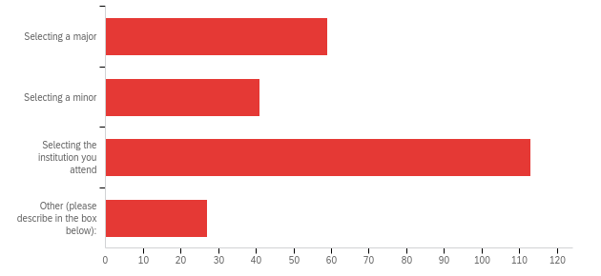

# | Answer | % | Count
1 | Selecting a major | 24.58% | 59
2 | Selecting a minor | 17.08% | 41
3 | Selecting the institution you attend | 47.08% | 113
4 | Other (please describe in the box below): | 11.25% | 27
 | Total | 100% | 240

Q8_4_TEXT - Other (please describe in the box below):
Other (please describe in the box below): - Text
No.
none
I've been given a substantial amount of financial aid which is why I chose UVa, however, I fear it will change in the next year, leaving me to not afford the cost. I have also steered away from high tech majors such as engineering or computer science due to the upfront costs of technology.
None
None
None but I received a lot of financial assistance from my parents during undergrad that allowed me not to take out student loans
n/a
no
None
N/A
selecting the classes I took
Course choice is priority
N/A
None of the above
Do I get protein in my meals this week
Selecting courses
I double majored but the institution where I got my degree I had to pick a "primary" major where I took more classes and a "secondary" one that would not require as many classes. I chose the primary partly based on cost.
Scheduling
N/A
N/A
None of the above.
Data science minor is almost all digital, textbooks accessible online so less costs
No
none
n/a

Reduction Measures - What measures have you taken to reduce your required course material costs throughout your college career? Check all that apply.
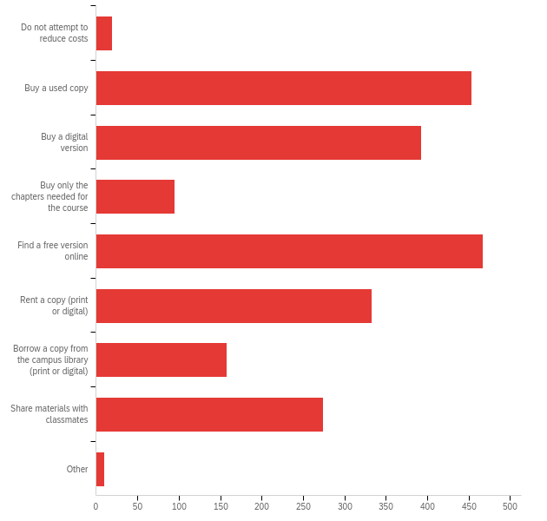

# | Answer | % | Count
1 | Do not attempt to reduce costs | 0.86% | 19
2 | Buy a used copy | 20.57% | 453
4 | Buy a digital version | 17.85% | 393
5 | Buy only the chapters needed for the course | 4.31% | 95
6 | Find a free version online | 21.21% | 467
7 | Rent a copy (print or digital) | 15.12% | 333
9 | Borrow a copy from the campus library (print or digital) | 7.18% | 158
12 | Share materials with classmates | 12.44% | 274
16 | Other | 0.45% | 10
 | Total | 100% | 2202

Other Measures - Please describe the other measure you have taken to reduce course material costs in the box below.

Please describe the other measure you have taken to reduce course material costs in the box below.
Not purchase
Alabama had program for students who had veteran parents.
Apply for research grants
Piracy
Borrow a book from an ebook library
Sometimes, myself and others will just not read or utilize the resource at all! It's sad but true.
pick which ones to buy and which ones to not use
not buy the materials
Avoided taking courses with required textbooks

Decision to Buy - When you have other options for getting your course materials (like renting), why would you choose to buy them? Check all that apply.
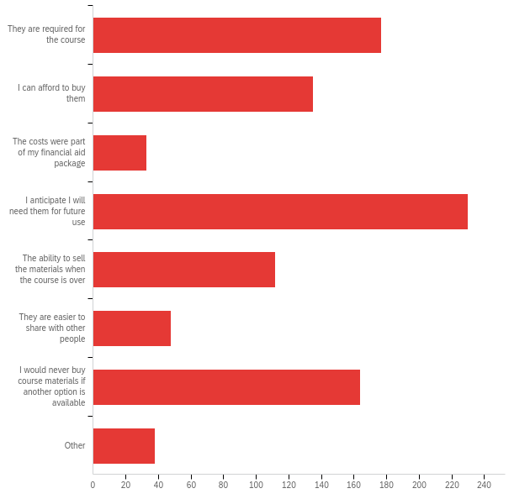

# | Answer | % | Count
1 | They are required for the course | 18.89% | 177
2 | I can afford to buy them | 14.41% | 135
3 | The costs were part of my financial aid package | 3.52% | 33
4 | I anticipate I will need them for future use | 24.55% | 230
6 | The ability to sell the materials when the course is over | 11.95% | 112
7 | They are easier to share with other people | 5.12% | 48
8 | I would never buy course materials if another option is available | 17.50% | 164
9 | Other | 4.06% | 38
 | Total | 100% | 937

Other Decision - Please describe the other reason you would choose to buy your course materials.

Please describe the other reason you would choose to buy your course materials.
Often rentals are not long enough to get me through finals
The materials go with online homework, so I needed to buy them.
easier than having to worry about returning them
They were only marginally more expensive to buy than rent.
The buying and renting options are priced comparably.
I've had campus libraries not accept my return due to quality of the copy because of bookmarking pages, underlining, etc. putting you on the hook for the cost.
Ability to mark up/highlight
Helpful to have physical copy to study
There is homework attached to it
I sometimes like to buy a hard copy as opposed to renting or getting an electronic version because sometimes I like to have the hardcopy textbook for future reference.
underlining in the materials is important
many literary texts aren't available for rent.
The ability to write in textbooks and manipulate them as I need to
If I buy course materials as opposed to renting them, particularly in regards to books, I can make my own notes on the pages.
The difference between rent and buy was so little.
For literature courses I need to annotate the books.
I like to write in them
to be able to write in them
I would buy them if the only other option is accessing them online because I think having a paper copy of my textbooks is a more effective studying tool.
I enjoy keeping my materials for future personal reference
Ease of access; no internet required to view materials.
Renting wasn't that much cheaper than buying. Also renting, more often than not, tends to be a digital copy compared to buying a physical copy.
There is digital access that is unable to be accessed without a purchase
Many courses require you to have a code for online work that is only available when buying a new textbook or subscription.
easier to read on paper rather than a computer
To be able to write in them, which I can't do for certain options like renting.
they're great books
Could be fun to read later.
same price as renting
Being able to alter and write in the textbook
May be cheaper than renting
I want them after the course (i.e. I liked a poetry book I had to buy for class a lot)
can write note on it
The prices are almost exactly the same and you can write in it if you own it.
If the cost of purchasing is near renting
I would like to write and take notes in the physical copy of the textbook.

Characteristics - Think back to past textbooks and course materials that you have chosen to buy and own instead of borrowing or renting. How important are the following characteristics that made them worthwhile to have?
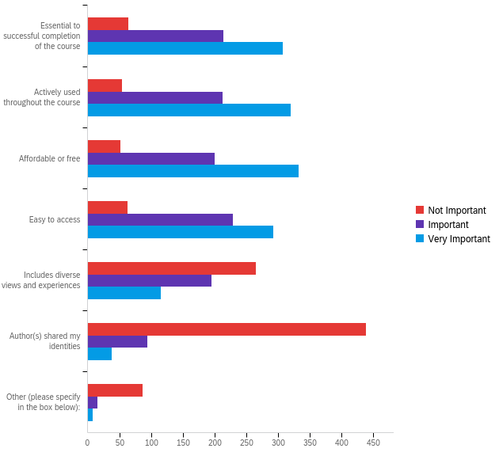

# | Field | Minimum | Maximum | Mean | Std Deviation | Variance | Count
1 | Essential to successful completion of the course | 1.00 | 3.00 | 2.42 | 0.68 | 0.46 | 586
2 | Actively used throughout the course | 1.00 | 3.00 | 2.45 | 0.66 | 0.43 | 587
3 | Affordable or free | 1.00 | 3.00 | 2.48 | 0.65 | 0.43 | 585
4 | Easy to access | 1.00 | 3.00 | 2.39 | 0.67 | 0.45 | 585
5 | Includes diverse views and experiences | 1.00 | 3.00 | 1.74 | 0.77 | 0.59 | 577
6 | Author(s) shared my identities | 1.00 | 3.00 | 1.30 | 0.58 | 0.34 | 571
7 | Other (please specify in the box below): | 1.00 | 3.00 | 1.28 | 0.59 | 0.35 | 110

# | Question | Not Important |  | Important |  | Very Important |  | Total
1 | Essential to successful completion of the course | 10.92% | 64 | 36.52% | 214 | 52.56% | 308 | 586
2 | Actively used throughout the course | 9.20% | 54 | 36.29% | 213 | 54.51% | 320 | 587
3 | Affordable or free | 8.89% | 52 | 34.19% | 200 | 56.92% | 333 | 585
4 | Easy to access | 10.77% | 63 | 39.15% | 229 | 50.09% | 293 | 585
5 | Includes diverse views and experiences | 46.10% | 266 | 33.80% | 195 | 20.10% | 116 | 577
6 | Author(s) shared my identities | 76.88% | 439 | 16.46% | 94 | 6.65% | 38 | 571
7 | Other (please specify in the box below): | 79.09% | 87 | 13.64% | 15 | 7.27% | 8 | 110

Format Preference - If the cost is the same, which format do you prefer for your course materials?
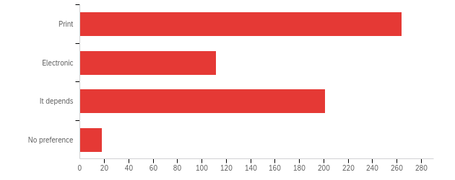

# | Field | Minimum | Maximum | Mean | Std Deviation | Variance | Count
1 | If the cost is the same, which format do you prefer for your course materials? | 1.00 | 4.00 | 1.95 | 0.95 | 0.90 | 595

# | Answer | % | Count
1 | Print | 44.37% | 264
2 | Electronic | 18.82% | 112
3 | It depends | 33.78% | 201
4 | No preference | 3.03% | 18
 | Total | 100% | 595

More About Format - Please tell us more about your format preference, including any relevance to accommodations:

Please tell us more about your format preference, including any relevance to accommodations:
I prefer to read print materials because I like the process of physically highlighting and it is much easier on my eyes. Reading electronic materials for every class can strain my eyes and is sometimes harder to read when the materials are scanned poorly.
If I need to be able to search through it for keywords, or if it is an open book class, then digital since I can index items easily. If I want to really retain info, print.
I like the format to be electronic because then I could access it on my computer.
Print is preferable because I feel like I remember things better and it doesn't strain my eyes as much.
I am more actively engaged by books in print and find that I remember more when reading a book in print.
Online Formats are preferred in almost every case
It is much easier to access a digital copy anywhere you are, but sometimes a hard print copy is easier to read/learn from.
Usually prefer print except when the course materials/textbooks become less readily accessible or dense
Print does not hurt my eyes as much to read and I like to be able to highlight etc.
I get tired of looking at so many screens.
I like to read print sometimes, since I am on the computer all the time.
I generally enjoy having the print version of the book for easy reference and to reduce eye strain/screen time, although if it is material that may be updated, and the digital version includes future published edition, that is a draw for me since the digital version would be more "shelf-stable" per se with built in updates. In addition, to save paper, I very rarely print articles and would not buy a hard copy of a book I anticipated only using briefly
I alway prefer print textbooks that come with a link to an online version for added convenience.
I love hard copy, but the ability to control f is also very useful.
If the class allows computers, I'll use digital. If the class doesn't allow them, I prefer print. I ideally would like both so I wont have to carry books around but could have access to either.
I have a terrible back please stop making me buy thousand page textbooks
Electronic is easier to access and use
I like online b/c it's easier on my back and can be accessed anywhere
No further info
I find it much easier to focus on print text compared to online versions -- I get very distracted with the internet -- I also find it easier to motivate myself to read since I can see the physical progress I've made through the book.
Online if textbook (easier to re-find material for studying), print if an actual book
For reading chapters for non-stem classes, I would prefer a hard copy as I can annotate but for classes like chemistry, I've found that I don't mind the online format, especially as they have little interactive quizzes sprinkled throughout and most of the material in the course can be found in the textbook.
electronic formats are easy to search terms, however physical copies of books are easier on my vision
easier to scan the text for key words or phrases
I prefer print but digital is nice to have on my laptop and iPad so I don’t have to carry them around
I definitely prefer having a physical textbook, but for some course it's easier and more convenient to have a digital copy. Sometimes digital copies can be cheaper depending on the subject, so that's also a factor.
It's easier to focus on a physical copy. However, I cannot print material at home, so it has to be a hardcopy i bought or a printed version provided by the professor.
Balancing searchability with electronic distractions
I enjoy electronic for efficiency (aka I can read it anywhere at any time) but I tend to like a printed copy to read since it is easier to annotate on.
Online or pdf’s are easier and lighter to carry around, but paper textbooks are better for eyesight long term.
I like online textbooks, but paper books.
For things like cs online textbooks are usually more convenient, but for other things I like having a physical copy of the material because it's easier for meet to read from that for long periods of time compared to screens
If I have to read from the book extensively I like to have a print copy because screens can hurt my eyes after a while. However, electronic books are much more convenient when it comes to using them in a library because I do not want to carry me heavy textbooks around with me.
I enjoy using print as I am able to physically take notes with the material
Yes, I have severe scoliosis so carrying around textbooks is not a great option and I typically now use online versions. However, personally, print copies are easier for me to actually read an focus on
When COVID happened, all we did everyday was look at the screen. It increased my headaches, and my computer battery was fried by using it excessively.
It just depends how into the course material I am. If it is a novel, I prefer it in print but textbooks I prefer to be electronic.
Electronic is easier to move around and usually cheaper and more accessible. Print are easier to read for long durations.
For materials on which I need to take extensive notes, I prefer electronic.
I'm an English major, that's writing a thesis, and so buying print materials is important to me so I can go through the text easily and make any annotations I need without worrying about returning any books or losing electronic notes.
Usually digital is cheaper so that is what I go for
I like print versions so the books are really expensive.
If it is an actual book (Novel, or narrative non fiction) then I like the book. If it just a honker of a textbook I prefer digital. Then I can search it as well via my computer.
If I will need to search for certain phrases or sections to succeed on assignments, it is much easier to have an electronic version. But I prefer to read print rather than on a screen.
I find hard copies of books much easier to study with and easier to mark up and follow for coursework.
I prefer print materials because they are easier to read than off a screen.
I prefer reading a physical textbook, and especially a physical book. However, digital copies make it very convenient to search for content.
It's ideal to have a paper format, because you're able to highlight, write-in, make notes in the textbook. It also allows for better spatial memorization
I prefer electronic textbooks because of their portability. I find the one major drawback to be that I cannot easily write notes or underline as I could with a physical copy that I own.
print books are easier to parse through.
I usually prefer electronic, but if it's not one we have to carry around to class with us but still have to refer back to often, a physical copy can sometimes be very useful. If it's one that has you constantly flipping pages to find something, I find that a physical copy works better. If the digital one is good and can help you find things quickly due to proper organization, a digital copy can save money and time.
Online is usually preferable to save space, but written is good for math and other handwriting-intensive courses.
It's weightless so I don't need to carry around another thing in my backpack. Since I only read it and don't need to write in it, it doesn't need to be print. It also saves trees
Can add PDF to iPad and search better.
I prefer to have a physical book for literary-based classes and a digital book for math/number-based classes.
It depends on the subject. For math and science, I'd rather have an online version, whereas for any other course I'd rather a print copy.
Print is often easier to access, mark-up Electronic is easier to share
I like print when its a novel that I would prefer to annotate. I like online textbooks to take notes from if I have to because I take notes on my computer.
Both....I prefer print when my eyes are tired from looking at electornic for so long.
Most of the time it is easier to search for certain keywords or phrases with electronic course materials. However, course materials like books are much easier in print form for both perusing and my eyes. It's also easier to carry around and does not need another device to access it.
I prefer print but can only afford online textbooks.
Longer reads - such as novels - I prefer in print format. Whereas, textbooks are satisfactory as online.
Textbooks are nice to have digitally, but other books such as novels are nice to have in paper-back form.
I work better when I can physically see what I have to learn and can then mark the pages with notes.
Studies show that it is easier to read via print. I find this true for me and it hinders my ability to learn when I have to rely on an ebook.
I prefer the electronic format because I almost always have my laptop with me which is more convenient than lugging around a heavy textbook. Also, I prefer if the electronic version of the textbook is accessible without the requirement of having Internet connection in case I am in a place with poor wifi or if I am traveling.
I prefer print for humanities classes and electronic for science classes. Print allows. for annotating and electronic allows for me to download the images that are very often in science textbooks.
I'd rather have free materials whenever possible.
Print tends to be easier to use for me, but I have found electronic sources useful especially when I need to quote large portions of text for notes.
I prefer online textbooks. They're usually cheaper, and easier to read.
I prefer to have a print copy as it is easier for me to retain information that way than reading online. With a print copy, I am also able to highlight and make notes as I read in the book which helps me when it comes to studying and reviewing.
print is easier to read and easier on vision since everything else is online, information is better retained
I prefer electronic textbooks because they are more convenient and easy to access and carry around.
I like print so I can still have my laptop out and not have to click through multiple tabs to get back to my assignment and e-book.
Digital is horrible.
N/A
Print versions are easier on my eyes and I do not get as fatigued. Print allows me to take better notes since I can focus more while reading print then online ebooks
I like being able to study anywhere on the go without having to carry my textbooks around but I also love the feel of a print textbook.
I can handwrite annotations and allows for better memorization.
I don't love staring at screens for hours at a time, I prefer to have a tangible book to hold and look at.
Some classes require print resources, other electronic. I prefer physical sources for novel-type sources so I can highlight and annotate, but electronic for textbooks since they are so large.
I like print copies because there is no lag when I turn the pages.
I get eye strain and headaches from spending too much time staring at a screen and from taking notes (looking back and forth between screen and paper and scrolling) so it is often frustrating that print versions cost more than digital, or when digital is the only option.
I like having both print and online options
For books I just need to read (not annotate), I prefer audiobook. I prefer e-books for ease of access if the book is highlightable.
I prefer reading physical textbooks but it’s hard to bring them along to classes. It’s nice having electronic copies because you can copy and paste things easily
I enjoy having a physical copy because I like being able to write in and highlight the book. Furthermore, physically copies are much less of a strain on my eyes.
cheap
Though it may be old-fashioned, I enjoy physical copies of books more than electronic sources, and I often retain more information from the material. Similarly, if I own the book, annotating and highlighting directly onto print material is a lot easier.
Electronic, for easier searching of keywords within the document.
It depends on the course I am taking and if i really want to keep the print material even after taking the class for future reference or print version will do for portability purposes
I prefer print format for smaller items (such as readings) and electronic format for bulkier items (such as textbooks)
for textbooks, online is better, but for individual books (novels, etc.) i prefer print
I personally would like a print copy, but realized that a electronic version may be easier for transport.
I like the tactile format and I have less distractions if I use print.
I prefer print because I like to highlight text and annotate. It’s useful to dogear pages that are important. It’s also nice to be able to see your progress with a physical copy rather than an electronic copy (motivates me to finish my work).
For some courses, it makes more sense for me to have a physical copy so that I can take notes, write in the margin, or easily open my book to use as a reference while simultaneously using my computer. Other resources are better to have as electronic, particularly when I want to find specific words and phrases and can "Ctrl-F" a lengthy file.
Print is easier to read and take notes alongside
It depends on the structure of the course (if it's mostly reading, if there are problem sets that go along with the course). Mostly reading, I'd want print copies, but mostly problem sets, I'd want it electronic.
for online classes, i prefer an online textbook
Books are easily to read and could be part of my book collection
I don't find it easy to read on the computer with font sizes changing and normally, pages getting messed up with images. Also, it's easier to highlight and make notes on paper books/readings than it is on computers.
The more interactive the online format--the more likely I'll engage with it (especially if there are little reminders on the side that state that practice qs are available re the material I just read instead of having to remember to look for the practice materials).
I like having paper copies for my English classes because I’m often annotating the text. I like having electronic for my STEM-based classes because it takes up less space and is just easier to use when taking notes.
Electronic is definitely convenient, but I stare at screens for like 18 hours a day, so I need a break from them.
If something has to be submitted within the textbook, it's easier for it to be virtual. Otherwise, print is better.
if there's a kindle copy, i'd prefer that. otherwise, print
Electronic is easier for certain texts like large textbooks because you don't have to carry them around and can access them whenever you an electronic device is available to you. For smaller books and novels I prefer print to give my eyes a break from screens.
Less screen time and easier to flip through if in print.
Print if permanent, electronic if otherwise
Reading on a screen gives me headaches.
I like digital and the ability to easily jump to sections and search for keywords
A printed version is easier to look over and is more accessible.
It depends on the class and the intensity in which the material is used. For stem classes it was easier for me to use the hardcopy especially because we did not need to bring the book to class. If we were using the book in class it is easier to get it hardcopy.
Reading on the computer is difficult for me, and I can study more effectively if I am reading a print version of the test.
Electronic - easier to transport and can write on the pdfs on an iPad
If the electronic version is free and print is not, I would prefer the electronic version, but if they're the same cost or if the electronic version is only slightly less, then I would prefer a print version, as it's far easier for me to absorb information in that manner
I prefer print books, but sometimes books have activities which are easier to complete online
for large textbooks the electronic versions tend to be more useful as you can use search, highlight, and comment functions more conveniently than writing in a real book. For books that are more reading/story based, a printed copy can be easier to use.
If I am buying a textbook, I like to have a hard copy!
I comprehend text better in print
Typically I prefer print books since figures are easier to read etc, but in books where figures are limited/ unimportant (humanities and math as opposed to science etc) I prefer electronic for the portability/accessibility
electronic makes it easier to search throughout the textbook for key words or concepts.
Depends on both the class and the specific media that is being presented
A physical copy, especially one I can write in, allows further synthesis of ideas and notes, of which I find crucial to my learning methods.
Digital is more portable and markable
I prefer print for literature-related classes. I prefer electronic for STEM-based classes.
I generally like print copies, but it is easier to get my hands on a digital copy more quickly (I have had to start doing readings for classes before the bookstore has gotten print copies in before). There are also digital platforms like Top Hat that make the textbook more interactive.
For readings that include a lot of diagrams and pictures, I like for it to be in paper format. However, if it was strictly just reading, digital copies are easier to use.
After being online for over a year it is nice to be off the computer when taking notes or reading.
I like being able to have access to the course materials from my phone and laptop because it makes the information more accessible, but I feel studying is easier with physical books
Physical textbooks are easier to mark for later reference with sticky notes, bookmarks etc. They also help me connect with the material better than a digital textbook.
Readings are better physical in my opinion. All else digital
An electronic copy is easier to carry around since it just on your laptop or whatever other technology you are using. It can also be cheaper in some cases.
Print makes it easier to take notes
Certain formats are conducive to learning in different classes. Often printed copies are favorable except in classes that require digital submission of textbook work.
I prefer print resources for the classes I find most interesting. I like to write in them and keep them on my bookshelf for future reference or review.
Sometimes online can be helpful
I will always pick the more budget-friendly option, which usually ends up being an online version or something used. It just depends on what is more affordable.
I prefer electronic format because it's easier to go back to certain sections in the text and find a specific part you were looking for. It's also more convenient because you can access them anywhere, and you don't have to carry around heavy textbooks.
I find it easier to understand and retain information I read in print.
I prefer print as some classes require the assignments be turned in from the textbook.
Short articles are fine digitally but I prefer print for longer books. For digital materials I want a professional scan so that it can be read by a text-to-voice app.
none
Print is just easier to read, take notes, be interactive with. I get much more distracted on e-resources. Also, I feel like I retain better from physical books.
I already spend so much time on the computer and using screens, so having a print version is easier on the eyes and on preventing headaches. It is also easier to take notes on, and it is just overall easier for me to use.
Books are better to have in paper, and textbooks are better to have online
For math related courses, I would prefer digital. For reading type courses, I would prefer a print copy.
I always prefer physical material to digital, however digital does allow better search functions.
It is easier for me to focus on physical, print materials than sources I have to read electronically.
I would rather convert my whole apartment into a mini library if I get free printed books that are necessary
Print is much easier for me to read than digital
Digitally accessed course materials are easier to bring to the library and are more easily accessed than requiring the physical copy.
If it is a large reading based book or novel, I prefer it to be printed, but if it is a textbook, I prefer to be a electronic version since it is easier to carry around.
I prefer to have paper copies of all work (textbooks, articles, etc.). Although it is often costly, I prefer to print articles and required readings that professors may upload to Canvas as PDFs, rather than read online. I do much better when I physically mark up texts and do not have to read them from a screen.
I prefer to be able to write in the book in the side to make notes.
While print is much easier to read and take notes with, electronic formats are usually more affordable so I tend to get those more.
There is more convenience with digital versions.
Ebooks, or digital textbooks are more often than not preferable to a physical textbook, however, some digital formats make the books borderline unusable or frustrating to use, specifically those that try to integrate extra features into the text, like videos, links, and pop-up windows.
See last short answer (print is easier!)
Digital, lessen physical weight of backpack. However, should be able to be accessed without wifi/offline
Sometimes it's nice to have a physical copy to highlight and annotate, but it's also nice to have an online resource as sometimes that can be easier,
PDF/paper copy if there are annotation requirements PDF if there are just reading requirmenets
It is so much easier to read the physical version. It gives me less of a headache and makes it easier to read in multiple different contexts. I can bring it around to classes with me, pull it out in class, find page numbers, make notes, and all sorts of other applications that are just not the same with the online version. Learning is easier when I can actually have the text.
A physical copy means that I physically have a book in my hands to keep. Many of the online formats expire after a period of time.
I usually prefer hard-copies over digital versions, and I almost always opt for pre-used copies.
I prefer things to be online as I primarily use an IPad to take notes and annotate. This is much easier to do if the books are already online rather than having to scan all of them into my app.
Electronic is the easiest, but I don’t really mind either
digital/electronic course material is more convient for studying and going to classes
if it’s more reading based, digital is fine. but if it involves analyzing diagrams and practice problems, i prefer print.
Electronic is much more portable.
I think it depends on the situation. For my music classes, I like a print textbook because we do more writing on it. But, for my computer science classes, I think it is easier to have all of the notes online.
90% of the time physical resources are much better for me to focus on than being on a computer.
Print format is much easier to read, especially during Zoom classes!
Harsh on eyes to read electronic versions and hard to annotate
As an older student, print tends to be easier for me to read than digital!
Easier to annotate print
I like print because I can highlight and easily bookmark and flip through the chapters

Learning Features - How helpful to your learning are the following course material features?
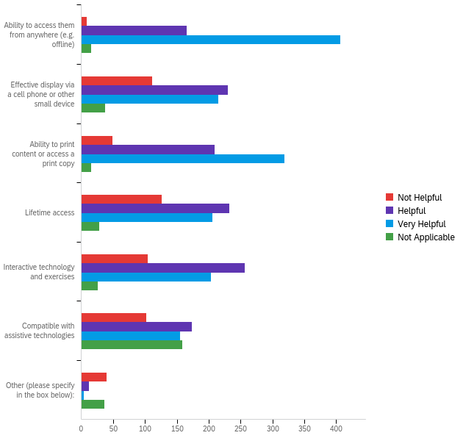

# | Field | Minimum | Maximum | Mean | Std Deviation | Variance | Count
1 | Ability to access them from anywhere (e.g. offline) | 1.00 | 4.00 | 2.72 | 0.53 | 0.28 | 595
2 | Effective display via a cell phone or other small device | 1.00 | 4.00 | 2.30 | 0.84 | 0.71 | 594
3 | Ability to print content or access a print copy | 1.00 | 4.00 | 2.51 | 0.68 | 0.47 | 593
4 | Lifetime access | 1.00 | 4.00 | 2.23 | 0.83 | 0.70 | 592
5 | Interactive technology and exercises | 1.00 | 4.00 | 2.26 | 0.80 | 0.63 | 589
6 | Compatible with assistive technologies | 1.00 | 4.00 | 2.63 | 1.06 | 1.12 | 589
7 | Other (please specify in the box below): | 1.00 | 4.00 | 2.39 | 1.37 | 1.89 | 92

# | Question | Not Helpful |  | Helpful |  | Very Helpful |  | Not Applicable |  | Total
1 | Ability to access them from anywhere (e.g. offline) | 1.51% | 9 | 27.73% | 165 | 68.24% | 406 | 2.52% | 15 | 595
2 | Effective display via a cell phone or other small device | 18.69% | 111 | 38.72% | 230 | 36.20% | 215 | 6.40% | 38 | 594
3 | Ability to print content or access a print copy | 8.26% | 49 | 35.24% | 209 | 53.79% | 319 | 2.70% | 16 | 593
4 | Lifetime access | 21.28% | 126 | 39.19% | 232 | 34.80% | 206 | 4.73% | 28 | 592
5 | Interactive technology and exercises | 17.66% | 104 | 43.46% | 256 | 34.47% | 203 | 4.41% | 26 | 589
6 | Compatible with assistive technologies | 17.32% | 102 | 29.37% | 173 | 26.32% | 155 | 26.99% | 159 | 589
7 | Other (please specify in the box below): | 43.48% | 40 | 13.04% | 12 | 4.35% | 4 | 39.13% | 36 | 92

Disability - Do you identify as having a disability as defined by the American Disabilities Act?
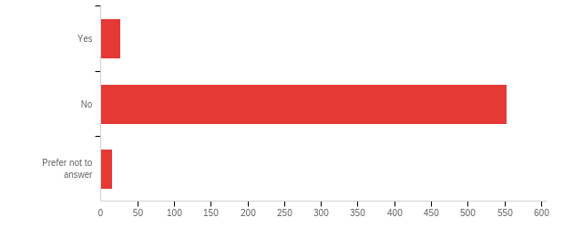

# | Field | Minimum | Maximum | Mean | Std Deviation | Variance | Count
1 | Do you identify as having a disability as defined by the American Disabilities Act? | 1.00 | 3.00 | 1.98 | 0.27 | 0.07 | 596

# | Answer | % | Count
1 | Yes | 4.53% | 27
2 | No | 92.79% | 553
3 | Prefer not to answer | 2.68% | 16
 | Total | 100% | 596

Effect of Disability - Does your disability affect how you use course materials?
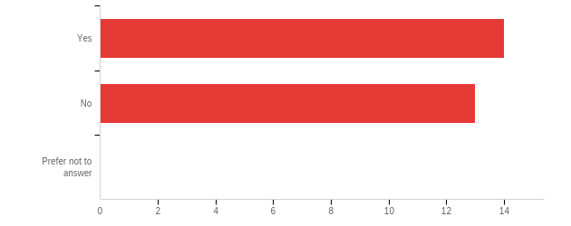

# | Field | Minimum | Maximum | Mean | Std Deviation | Variance | Count
1 | Does your disability affect how you use course materials? | 1.00 | 2.00 | 1.48 | 0.50 | 0.25 | 27

# | Answer | % | Count
1 | Yes | 51.85% | 14
2 | No | 48.15% | 13
3 | Prefer not to answer | 0.00% | 0
 | Total | 100% | 27

Race/Ethnicity - Which race/ethnicity do you identify with? Check all that apply.
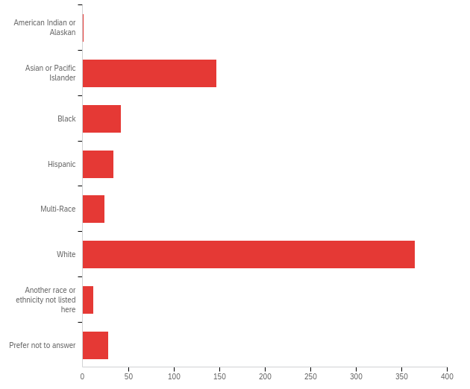

# | Answer | % | Count
6 | White | 55.90% | 365
2 | Asian or Pacific Islander | 22.51% | 147
3 | Black | 6.43% | 42
4 | Hispanic | 5.21% | 34
8 | Prefer not to answer | 4.29% | 28
5 | Multi-Race | 3.68% | 24
7 | Another race or ethnicity not listed here | 1.84% | 12
1 | American Indian or Alaskan | 0.15% | 1
 | Total | 100% | 653

Other Race - Please specify the race or ethnicity you identify with.
Unable to export widget. Please contact Qualtrics Support.

Gender Identity - How do you describe your gender identity? Check all that apply.
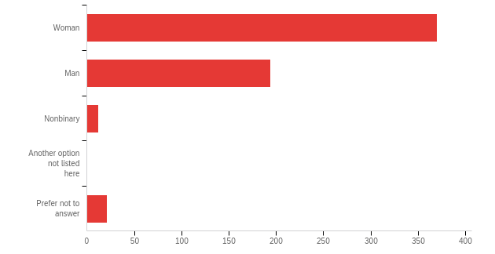

# | Answer | % | Count
1 | Woman | 61.98% | 370
2 | Man | 32.50% | 194
3 | Nonbinary | 2.01% | 12
4 | Another option not listed here | 0.00% | 0
5 | Prefer not to answer | 3.52% | 21
 | Total | 100% | 597

Other Gender - Please specify your gender identity.
Please specify your gender identity.

Funding Sources - Which of the following sources are you using to fund your education? Check all that apply.
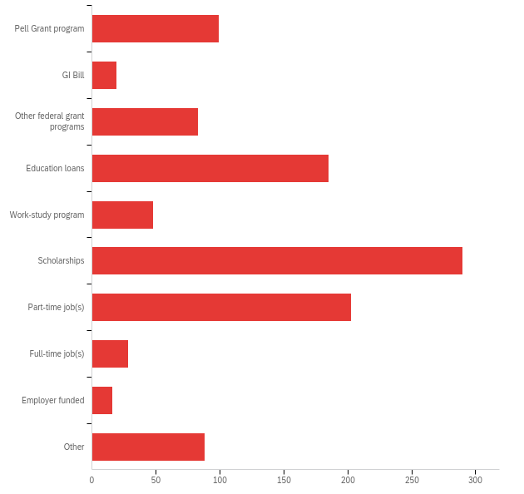

# | Answer | % | Count
1 | Pell Grant program | 9.35% | 99
2 | GI Bill | 1.79% | 19
3 | Other federal grant programs | 7.84% | 83
4 | Education loans | 17.47% | 185
5 | Work-study program | 4.53% | 48
6 | Scholarships | 27.38% | 290
7 | Part-time job(s) | 19.17% | 203
8 | Full-time job(s) | 2.64% | 28
9 | Employer funded | 1.51% | 16
13 | Other | 8.31% | 88
 | Total | 100% | 1059

Other Funding - Please specify the other source you use to fund your education.

Please specify the other source you use to fund your education.
Savings, assistance from family
ACCESSUVA grant
VMSDEP
Parents
Access UVA
Savings
Family contribution
Savings
my parents pay for my education
Parents
Family
Family-funded
I worked immensely throughout high school and am using the funds I collected to pay for the expenses.
small assistance from work
My husband is paying for my education at the moment out of pocket. I have previously taken out loans at other schools to pay and tried to get pell grants.
Fellowships/stipends
Parents
Parental assistance
N/A
Family savings
Parents
parents
I'm fortunate enough to have parents who started a college fund for me when I was born and to pay for my undergraduate education
Parental support
Parents 529
RA
Savings, summer job
Family support
Parents
Parents
My grandparents set up a college fund when I was born and they are paying for it.
family
Family income
Family
Fellowship
personal money
University grant aid
I am extremely priveleged and my parents pay for my education, they are at a high enough income that I usually don't need to worry about funding my education.
Parents
Will
Savings
Parents
Parents
Financial aid from the university
Institutional grants
Family money
parents
Personal Funds
My parents
My family supports my education.
529, Parents
Parents
529 Savings account
Family funded education
VA529
My parents pay for my education using money they have saved up.
Parents
My parents and my job
parents
Parents
parents
Parents
Graduate Teaching Assistantship
Family
Help from parents
Family
Parents and past job
PhD funded through department
College fund set up by my parents
savings
Parent's savings.
Parents
Virginia529
Parent funded
Family

Effect of Employment - How does your employment affect your academic success?
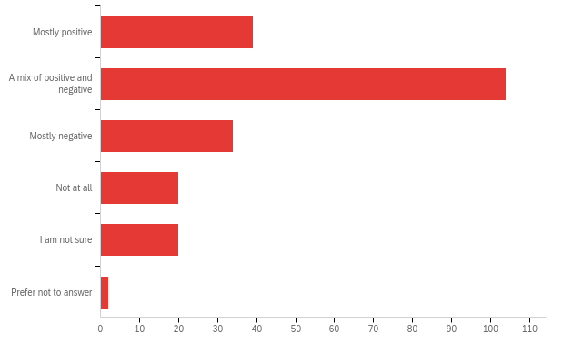

# | Field | Minimum | Maximum | Mean | Std Deviation | Variance | Count
1 | How does your employment affect your academic success? | 1.00 | 6.00 | 2.47 | 1.20 | 1.45 | 219

# | Answer | % | Count
1 | Mostly positive | 17.81% | 39
2 | A mix of positive and negative | 47.49% | 104
3 | Mostly negative | 15.53% | 34
4 | Not at all | 9.13% | 20
5 | I am not sure | 9.13% | 20
6 | Prefer not to answer | 0.91% | 2
 | Total | 100% | 219

First Gen Student - Do you identify as a First Generation Student, defined here as having no parent or guardian who completed at least an Associate's degree or higher?
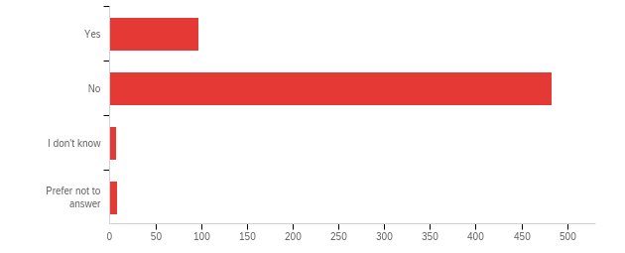

# | Field | Minimum | Maximum | Mean | Std Deviation | Variance | Count
1 | Do you identify as a First Generation Student, defined here as having no parent or guardian who completed at least an Associate's degree or higher? | 1.00 | 4.00 | 1.88 | 0.46 | 0.21 | 595

# | Answer | % | Count
1 | Yes | 16.30% | 97
2 | No | 81.18% | 483
3 | I don't know | 1.18% | 7
4 | Prefer not to answer | 1.34% | 8
 | Total | 100% | 595

Dependents - Are you currently taking care of children, parents, or other family members?
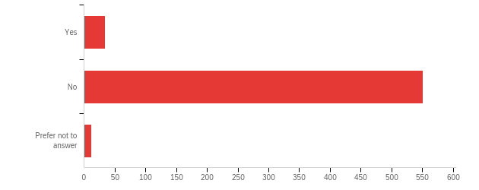

# | Field | Minimum | Maximum | Mean | Std Deviation | Variance | Count
1 | Are you currently taking care of children, parents, or other family members? | 1.00 | 3.00 | 1.96 | 0.28 | 0.08 | 597

# | Answer | % | Count
1 | Yes | 5.70% | 34
2 | No | 92.29% | 551
3 | Prefer not to answer | 2.01% | 12
 | Total | 100% | 597

Other Categories - Do you identify as any of the following? Check all that apply.
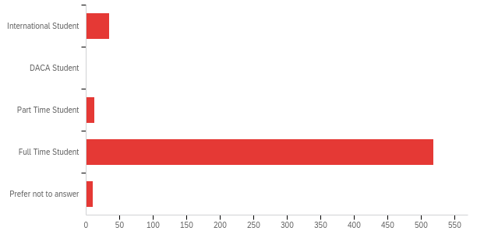

# | Answer | % | Count
1 | International Student | 5.92% | 34
2 | DACA Student | 0.00% | 0
3 | Part Time Student | 2.09% | 12
4 | Full Time Student | 90.24% | 518
5 | Prefer not to answer | 1.74% | 10
 | Total | 100% | 574

Age - How old were you when you started your current academic program? (enter a number in the text box below)

# | Field | Minimum | Maximum | Mean | Std Deviation | Variance | Count
1 | How old were you when you started your current academic program? (enter a number in the text box below) | 7.00 | 62.00 | 19.91 | 4.58 | 20.96 | 571

Other Identities - Is there any aspect of your identity that we have not covered in the preceding questions that we may want to consider including in future studies? Please use the space below.

Is there any aspect of your identity that we have not covered in the preceding questions that we may want to consider including in future studies? Please use the space below.
socioeconomic status - I am a low-income student.
N/a
Low-income
A lot of students have to pay for their textbooks themselves instead of their parents buying textbooks for them.
No.
Muslim
Whether we worked before coming to school and used savings for textbooks
N/A
No
N/A
Again, I am both a lower-income and first generation student, from a single parent household. Because of COVID-19, my family lost the little financial stability we had and I have helped financially in some aspects while also taking on a more mature role as my mother gets older and more tired.
i have little financial help from my employer, plus, as a part-time student, i don;t qualify for most assistance at school
No
I am an older student finishing my education after being in the workforce. I started community college right after high school, but took time off to work for a few years before coming back to finish my associates degree then apply for a four year program. I am more financially stable and able to more easily pay for my schooling now than I was in the past, but I am an exception. A lot of older students are not as fortunate.
Transgender identity (trans individuals statistically have lower income and fewer job opportunities, making university affordability a huge priority)
no
No
I am engaged to be married next year (summer 2022), which affects my financial situation in both positive and negative ways.
First generation immigrant
n/a
I am married
No
I have ADHD.
no
low income first gen
N/A
N/A
Are you from a two-parent household and do you parents provide sufficient funding for your education are two questions that would be helpful to consider.
N/A
Familial income. SES background affects the affordability of textbooks.
No
N/A
Mental Health specific questions
N/A
Economic status feels important here. As in, an approximated family income.
on full financial aid ride bc poor
No
NA
n/a
no
n/a
Maybe sense of belonging at UVA? This may affect whether people have communities where they feel comfortable sharing textbooks and course materials.
No
no
no
N/A
Member of LGBTQ+ community, first generation immigrant
As a doctoral student writing a dissertation, course materials are not really applicable to my case.
no
Family of 6- parents paid/ are paying for 4 siblings who all attended college as well.
No
No
Parent of small child
I'm homosexual
No
N/A
Gay
No
n/a
In future studies, ask students taking this survey, if they felt excluded by the high costs of homework access codes and textbook costs.
N/A
Student of non-traditional age, with more financial resources than many college students but also many more financial obligations and responsibilities.
No
Major! Different majors have different resource needs. Different resources have different availability
No
N/A
No
Nope.
For my doctoral program, I have been both a full-time student working part-time and a part-time student with a full-time job.
No
N/A
Architecture student
No
No
No!
No
no
Gamer
Disabled which means i cannot use electronic versions because i get migraines.
none
n/a
No
student-athlete
No
NA

