University of Virginia Library: Association of Research Libraries Rankings

Below are the University of Virginia Libraries' rankings in the ARL Investment Index. The rankings are determined by four variables: total library expenditures, salaries & wages of professional staff, total library materials expenditures, professional & support staff FTE. There are 116 university libraries in ARL.

Top 35 ARL Ranked Libraries FY20
Ranking | Institution Name
1 | HARVARD
2 | YALE
3 | TORONTO
4 | COLUMBIA
5 | MICHIGAN
6 | NEW YORK
7 | PRINCETON
8 | PENNSYLVANIA
9 | CALIFORNIA, LOS ANGELES
10 | PENNSYLVANIA STATE
11 | CALIFORNIA, BERKELEY
12 | TEXAS A&M
13 | ILLINOIS, URBANA
14 | DUKE
15 | CORNELL
16 | OHIO STATE
17 | SOUTHERN CALIFORNIA
18 | EMORY
19 | WASHINGTON
20 | JOHNS HOPKINS
21 | TEXAS
22 | MINNESOTA
23 | VIRGINIA
24 | INDIANA
25 | WISCONSIN
26 | MICHIGAN STATE
27 | RUTGERS
28 | PITTSBURGH
29 | NORTH CAROLINA
30 | IOWA
31 | NORTH CAROLINA STATE
32 | NORTHWESTERN
33 | FLORIDA
34 | GEORGE WASHINGTON
35 | WASHINGTON U.-ST. LOUIS

ARL Rankings FY03-FY20

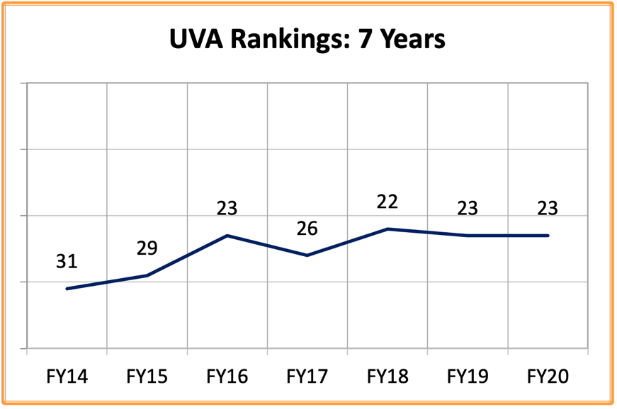

Year | UVA Ranking
FY03 | 27
FY04 | 22
FY05 | 20
FY06 | 19
FY07 | 24
FY08 | 24
FY09 | 27
FY10 | 33
FY11 | 30
FY12 | 32
FY13 | 34
FY14 | 31
FY15 | 29
FY16 | 23
FY17 | 26
FY18 | 22
FY19 | 23
FY20 | 23

